User Guide
jWebSocket
Ping-Pong Game <1.0>

1. Characteristics of the solution
Ping-Pong game allows users to play each other online in real time on the Web. Users can play in pairs, ie each other and consistency of the attributes of the avatars is updated in real time. It also keeps track of the games through a ranking which is updated instantly whenever a match is terminated. The same does not consume resources of the client, the network latency value reaches deal, is interactive, including. It differs from other games in real-time Web, which is built on the framework jWebSocket and thus demonstrates the potential that presents the framework for developing jWebSocket Web games in real time.
JWebSocket servers show good scalability of the connections. Tests to show jWebSocket server as a result 10 000 concurrent connections without affecting the response time of the application. This element ensures perform real-time process and a high number of users using the same service at the same instant of time. This aspect of the competition provides an important impact as it allows 10 000 people can connect to the game of Ping-Pong from different countries and at the same instant.
2. Main functionalities
Functionalities of Ping-Pong Game:
- User registration.
- Allow user authentication and password.
- Disconnect user.
- Show users online.
- Make a request to start.
- Email notify umpire of agreement or disagreement with the invitation.
- Create split between two users.
- Move player.
- Start Game.
- Delete game created.
- Show Help.
- Show scores.
- Save data starting at the end of this.
- Pause game.
- Show the ranking of the players.
- Chat show.
- Enable and disable sound.
Among other issues, Ping Pong Game can be viewed from disparate parts of the world for thousands of people. Access is possible from both stationary and mobile devices, making it a potential tool for education and knowledge management on the Web.
This application differs from other games that are built on the framework jWebSocket. In addition to achieving real time on the web with new WebSocket protocol and demonstrates the potential that presents the framework for conducting jWebSocket Web games in real time.

3. Problems to be solved.
Problem | Contributions of the solution
Latency online games on the web. | Ping-Pong game is a Web application that enables you to play a couple in real-time online through the WebSocket protocol.
Online games on the Web that are communicated in a way. | Ping-Pong game communicates bi-directionally through the WebSocket protocol.

4. Glossary of Terms
Web Games: Multimedia applications to play networked virtual environments such as the Internet or local area networks, which run from a Web browser (Internet Explorer, Mozilla Firefox, Opera, Google Chrome, etc.).
Real time on the Web: It is possible when the client receives messages from the server without prior request and end users receive updates simultaneously.
WebSocket: It is a technology that provides a bidirectional communication channel and full-duplex over a single TCP socket. This protocol solves the limitations of HTTP, by establishing a full-duplex communication (TCP) between the client and server, replacing the half-duplex communication (HTTP). Is reduced, in large proportions, the network traffic given that WebSocket to establish communication between the client and the server there is only one shipment of 2 bits, eliminating the HTTP headers.
JWebSocket framework: Is a new technology aimed at developing WebSockets based applications that provide high levels of speed, scalability, security and real-time work, a key element for online collaboration today.
Full-Duplex: Quality of the elements that allow the input and output data simultaneously.
Socket: Method for communication between a client program and a server program on a network.
Half-Duplex: Means that the method or protocol for sending information is bidirectional but not simultaneously.
5. Model of the solution
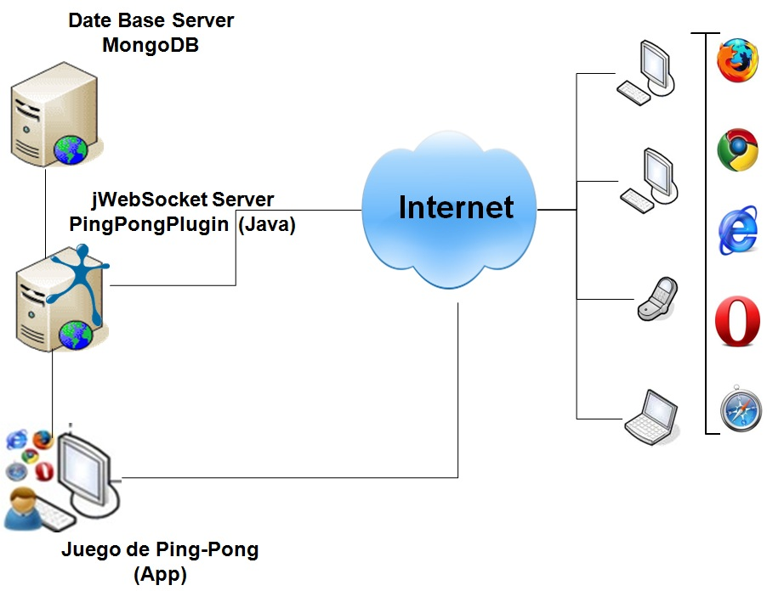

To access the Ping-Pong game the client must use a browser that supports WebSocket protocol. Then you must authenticate to the application to display the players who are online and request an application so that we can play. The actions that are performed by the player are sent to the server jWebSocket, which is responsible for distributing over the Internet to other players in real time.
6. Requirements for Use
To use the Ping-Pong game must have Internet access and use any of the browsers that support the communication protocol WebSocket. Some of them are Google Chrome 4+, Safari 5+, Mozilla Firefox 8+, Opera 11+ e Internet Explorer 10+.

7. Roles of the solution
System User: Interacts with the application, you can perform all actions that provides the same.
8. System Operation
Initial view log: Allows users to register or create an account in the application.
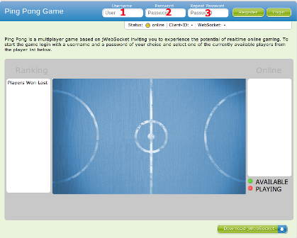
1 -------- Field where the user inserts the identifier to be in the application.
2 -------- Field where the user inserts your password.
3 -------- Field where the user repeats the password to verify it is correct.
-------- Save user information.

Loquearse initial view: Allows users to loqueen (access) to the application.
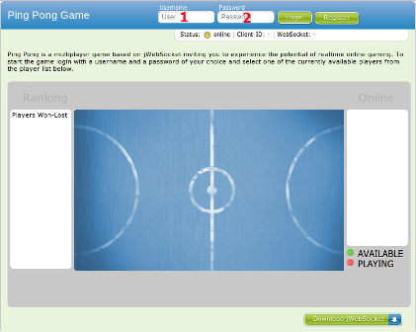
1 -------- Field where the user enters his ID to access the application.
2 -------- Field where users enter their password to access the application.
-------- Access the application.
Main view: Allows users to request a game. Besides showing some statistics.
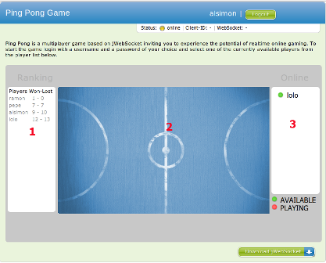
-------- Exit the application.
1 -------- Displays a list of players ordered by descending ranking.
2 -------- Displays the setting for which to play.
3 -------- Show the users that are connected, which are green you can request a game and those in red are playing a game.
Main view of departure: Allows users to play the game.
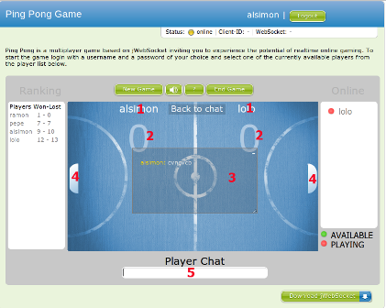
1 -------- Displays the identifier of the players.
2 -------- Show scores of the players.
3 -------- Talks shows users who are playing (Chat).
4 -------- Displays the rackets of the players.
5 -------- Field where the user enters the chat conversations.
-------- Start a new game.
-------- Stop and continue the game (pause).
-------- Brief description of how to play (help).
-------- Eliminates the game.
-------- Turns the sound.

9. Rules of the solution
R1: If the user during the registration process introduces an existing user, the system issues an error message and continues with the normal flow.
Solution: The user can enter another user and re-register.
R2: If the user is wrong to repeat the password during the registration process, the system issues an error message and does not continue with the normal flow.
Solution: The user must repeat the password again to confirm.
R3: If the user mistype your username or password, Access during the implementation, the system issues an error message and continues with the normal flow.
Solution: The user must repeat your username and password again.

